**2D FEM with Higher Order Basis Functions**

*Authors: Adedayo Lawal and Blake Levy*

**Abstract – A two dimensional finite element method (FEM) simulation is presented. An obliquely incident plane wave propagates through an inhomogeneous media backed with a perfect electric conductor (PEC).**

1. **INTRODUCTION**

In various types of computational sciences, the reduction of one spatial dimension can reduce the computational cost. For an obliquely incident plane wave onto an inhomogeneous dielectric slab in two-dimensional space, analysis can be performed without any loss of generality in a one-dimensional space. Figure 1 shows an obliquely incident plane wave on a dielectric space backed by a PEC in two dimensions and its reduction into one dimension respectively.

Figure 1 Left: 2D problem. Right: 1D simplified version

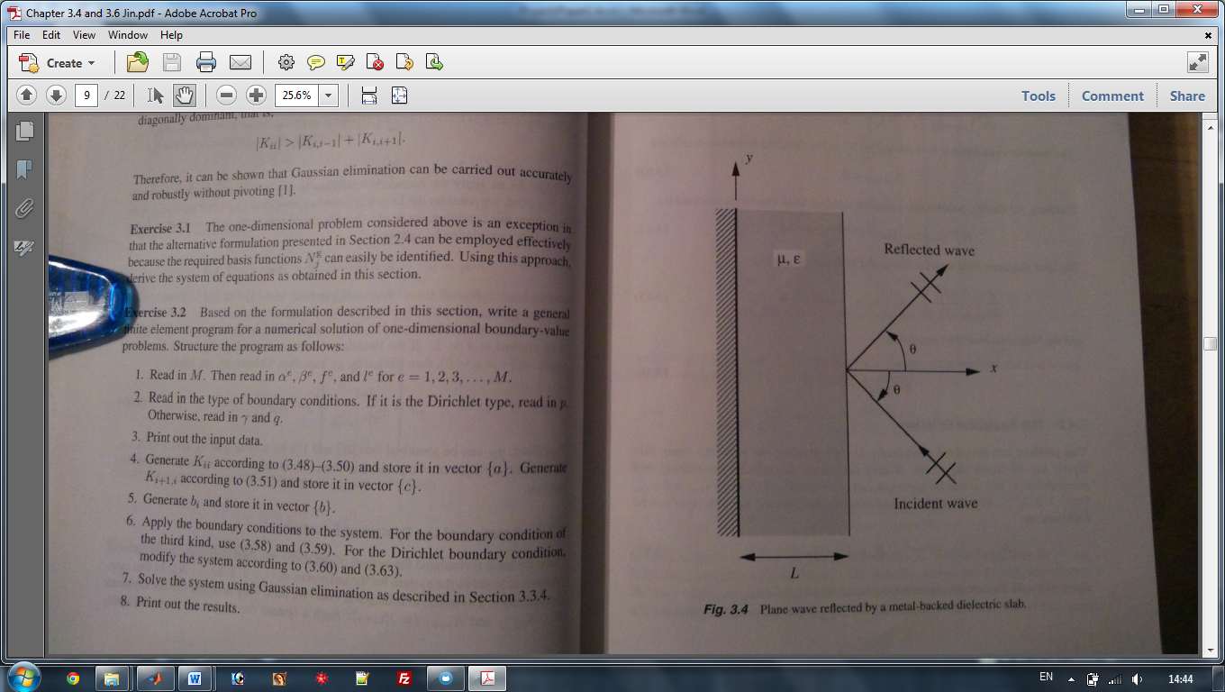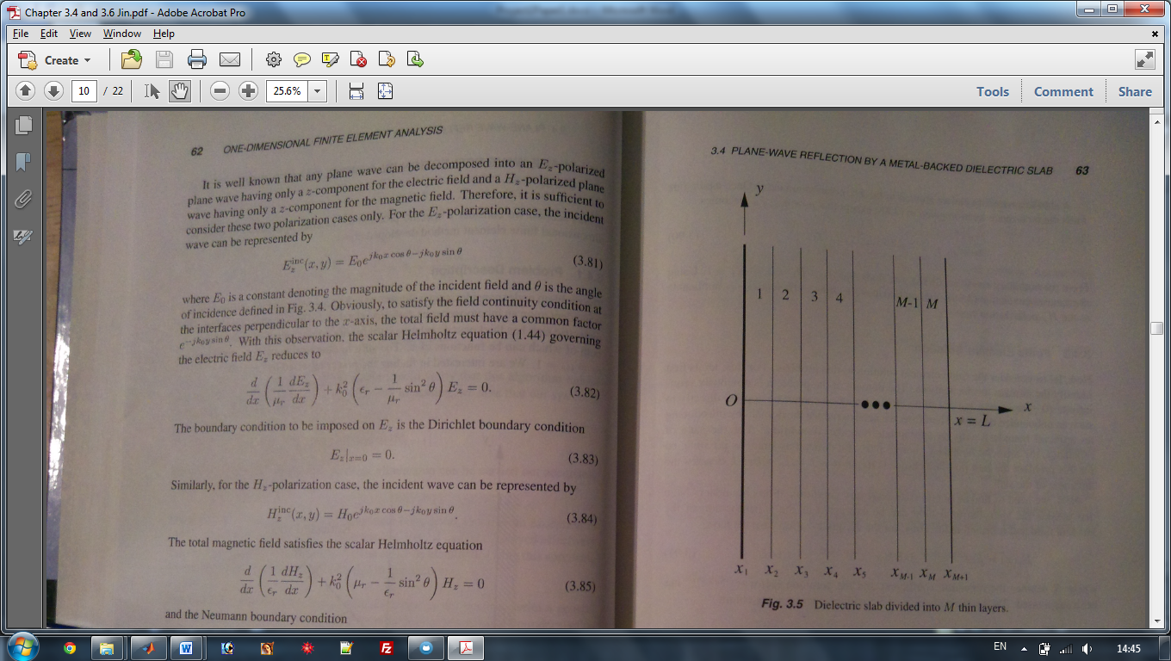

1. **FORMULATION**
   1. **Parameter Initiation**

The dielectric slab used in the project was required to be inhomogeneous. While there are an infinite number of permittivity profiles, we chose to use the same variation as defined by Jin [1] where inside the slab the relative permittivity and permeability varied as follows: $ε_{r}=4+(2-j0.1){(1-\frac{x}{L})}^{2}$ and $μ_{r}=2-j0.1$. Adjacent to the slab on one side was a medium filled with free space whereas the other side consisted of a PEC material.

As a result of the one dimensional analysis, the dielectric slab can easily be split into M elements with N number of nodes as shown in Figure 1. In the subsequent section it is evident that error decreases as M and N increase.

* 1. **Fundamental Equations**

Fundamental equation: $\frac{∂}{∂x}\left(\frac{1}{μ_{r}}\frac{∂E_{z}}{∂x}\right)+k_{0}^{2}\left(ε_{r}-\frac{1}{μ_{r}}\sin^{2}{θ}\right)E_{z}=0$

Matrix Equations:

and

* 1. **Boundary Condition**

The use of a PEC boundary at one end of the dielectric slab requires the electric field to be zero. At the interface between the dielectric slab and free space, it can be proven that the electric field should follow equation 2.3.2.

* 1. **Higher Order Basis Functions**

In the finite element method, basis functions are used to approximate a particular solution. Linear basis functions or first order elements have advantages and disadvantages. Linear elements are typically simpler to code than higher order elements, however they suffer from slow convergence and poorer accuracy. For this reason, we have established solutions based on quadratic and cubic order basis functions.

1. **RESULTS**
   1. **Error**
   2. **Gaussian Quadrature**
2. **CONCLUSION**
3. **REFERENCES**
4. J. Jin, *The Finite Element Method in Electromagnetics*, 2nd edition, Wiley, 2002.